THE ICS CENTENARY GOLF TOURNAMENT
Dear Golfer

You are invited to be part of our 3rd Annual Golf Day,

on Thursday 8th of September 2011

At Royal Johannesburg & Kensington Golf Course
(East Course)

Tee off Times
11h45 – 13h15
1st & 10th Tees

(FOURBALL BETTERBALL STABLEFORD)

The centenary golf tournament will be followed by a hot meal/prize giving.

This is an Institute of Chartered Shipbrokers’ Fund Raiser
We require sponsors and players to assist us in this fund raising effort.

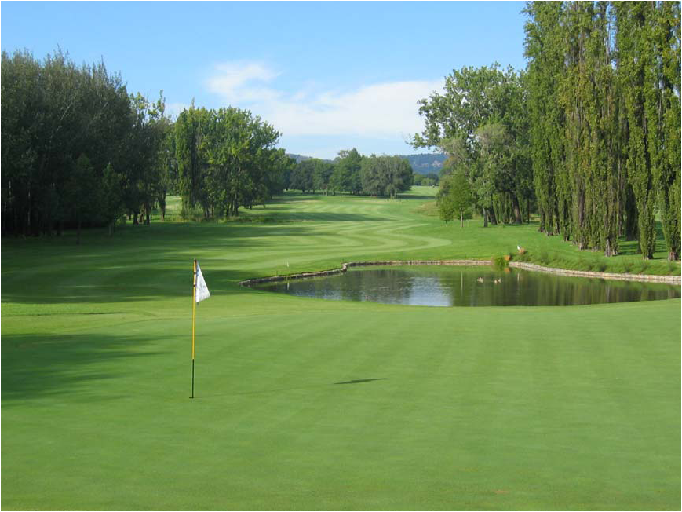

FOURBALL ENTRY – R2000 per team of 4 players

Company Name
Contact Person
Tel No.
Fax No.
Email

Player’s name | Email | Handicap | Shirt Size | MECC mem

Note: The entry fee includes green fees a hot meal/prize giving after the tournament

Carts, Caddy fees, Sand Bags, Halfway House and Drinks are for your own account.
(Carts and Caddies are to be reserved directly with the Pro shop on 011 485-4899)

SPONSORSHIP

We would like to sponsor one or more holes at R1600 each.

Number of holes: …………… Hole number/s (if any preference) ……………..

We would like to donate a gift / prize:

Gifts | Number
Golf shirt/s
Golf umbrella/s
Golf balls/tees
Other (please specify)

Amount Payable
Sponsorship | R
Fourball Entry/s | R
Total | R

Sponsors only, may display logos, flags and signboards around the course and putting green.

To facilitate arrangements please complete and return this form preferably by email
to Pauline on pauline@ics.za.org or by fax on 0865085224 by no later than 25/08/2011

A tax invoice will be issued on request: YES / NO (delete that which is not applicable)

Payment is to be made before the date of the function.

Account in the name of:
The Institute of Chartered Shipbrokers SA Branch
ABSA Bank
Branch No. 632005
Acc No. 4074174601

NB: Having notified us of your acceptance, you will be charged in the event of your non-attendance.
(You will be required to email or fax a clear copy of the deposit slip through to 086 508 5224)

